
PERSONAL SHOPPING ASSISTANT (E-COMMERCE AGENT)
PROJECT REPORT

MNU
Amira Emad Selim

Agientic AI using Langchan
Faculty Training
DR Nehal Tarek - Eng Rahma Ashraf
Name : أميرة عماد إبراهيم بهجات سليم
ID : 20230056

SECTION 1: TRAINING PROGRAM DETAILS
1.1 Introduction and Training Overview
The training program provided a comprehensive curriculum covering foundational and advanced concepts in Natural Language Processing (NLP), Large Language Model (LLM) orchestration, vector embeddings, information retrieval, Retrieval-Augmented Generation (RAG), and multi-agent systems. Using frameworks such as LangChain, LangGraph, and LiteLLM Proxy, the primary objective was to learn how to transition from static generative models to practical applications capable of reasoning, retrieving external context, maintaining conversational state, and handling human-in-the-loop workflows.
1.2 Mathematical Foundations: Word Embeddings & Vector Space Logic
1.2.1 From One-Hot Encoding to Dense Vectors
Before modern vector embeddings, text representation relied heavily on one-hot encoding, where words were mapped to discrete indices in a fixed vocabulary. Under this approach, a vocabulary of size $N$yields sparse vectors of length $N$containing a single non-zero value ($1$) at the word's index. The training highlighted two main limitations of one-hot representations: high computational and memory overhead due to large zero-filled vectors, and an inability to capture semantic relationships, as orthogonal one-hot vectors treat all words as equally distant from one another.
1.2.2 Feature Representation & Unsupervised Learning via Prediction
Modern word embeddings map words to dense numerical vectors where each dimension represents abstract, learned latent features. Neural networks learn these weights through prediction tasks, such as predicting missing tokens given surrounding context. During backpropagation, network weights are iteratively updated to minimize cross-entropy loss, naturally grouping contextually similar terms closer together in the vector space.
1.2.3 Vector Geometry & Similarity Metrics
Embedding models establish mathematical relationships across multi-dimensional space. To evaluate geometric similarity between vectors, two primary metrics were analyzed:
- Euclidean Distance ($L_{2}$ Norm): Measures the straight-line spatial distance between two points

While useful, Euclidean distance remains sensitive to differences in vector magnitude rather than direction.
- Cosine Similarity: Evaluates the cosine of the angle ($θ$) between two vectors, focusing on directional alignment and semantic closeness
When vectors are $L_{2}$-normalized to unit length ($‖A‖=‖B‖=1$), cosine similarity relates directly to squared Euclidean distance, making spatial comparisons computationally efficient.
1.3 LLM Orchestration with LangChain
1.3.1 Core Architecture, Models, and Roles
LangChain provides a framework for connecting language models to external data and execution tools. The training covered the distinction between single-turn text completion models and chat models designed for multi-turn conversations. Chat models use three fundamental operational roles:
- System Message: Defines agent identity, instructions, domain constraints, and guidelines.
- User Message: Captures incoming user queries or commands.
- AI Message: Stores generated model responses to preserve conversation history.
1.3.2 Token Dynamics and Context Window Constraints
Language models do not process raw text directly; inputs are parsed into sub-word tokens that directly affect latency and API usage costs. The context window defines the maximum token limit a model can process in a single pass. Exceeding this boundary causes input truncation or
1.3.3 Prompt Engineering & Structured Outputs
To guide model behavior and obtain predictable outputs, several prompt design techniques were explored:
- Chain-of-Thought (CoT) & Role Priming: Prompts the model to break down complex tasks step-by-step while adhering to a specified persona.
- Structured Output Enforcement: Uses schema validation tools (such as Pydantic models, typed dictionaries, or native JSON parameters) to enforce required output formats rather than plain text.
- Output Parsers vs. Direct Schemas: Compares schema-constrained generation against post-generation parsing mechanisms designed to clean or extract structured data from raw strings.
1.3.4 Execution Strategies: Runnables & LCEL
Using the LangChain Expression Language (LCEL), execution components are combined modularly. Standard execution paradigms include single-input invocations (invoke), batch processing (batch) to handle concurrent requests, and streaming (stream) to display output tokens incrementally.
1.4 State, Memory, and Tool Integration (ReAct Paradigm)
1.4.1 Memory Architecture Strategies
Because standard model API endpoints are stateless, previous conversation history must be re-submitted with each request. The training analyzed four main strategies:
- Buffer Memory: Retains the complete conversation history, offering full context at the expense of growing token consumption.
- Window Memory ($k$-Window): Retains only the most recent $k$message exchanges, setting a fixed token limit.
- Summary Memory: Uses a background LLM call to continuously summarize older dialogue.
- Hybrid Memory: Combines background summarization for older context with a verbatim window for recent turns.
1.4.2 The ReAct Agent Framework
Complex problem-solving can be structured using the Reasoning and Action (ReAct) pattern, which iterates through four steps:
- Thought: The model analyzes user intent and current state to determine the next step.
- Tool Call: The model selects a tool and generates its arguments.
- Tool Execution: The runtime executes the local function or external API.
- Observation: The execution result is added back into the context as a tool message, informing subsequent reasoning steps.
1.5 Retrieval-Augmented Generation (RAG) Architecture
1.5.1 Document Loading & Advanced Chunking Techniques
RAG architectures help ground responses in external documents to reduce hallucinations. Processing begins with specialized file loaders for raw text, PDFs, or structured data. Documents are then split into manageable chunks:
- Recursive Character Text Splitting: Uses a hierarchy of separators (e.g., \n\n, \n, space) to split text while preserving paragraph and sentence integrity.
- Semantic Chunking: Computes distance metrics between embeddings of consecutive sentences, inserting breaks when semantic distance exceeds a specified threshold.
1.5.2 Vector Stores, Indexing Mechanics, and Record Management
Generated embeddings are indexed in vector stores using efficient search structures such as Hierarchical Navigable Small World (HNSW) graphs. To maintain index synchronization, record management layers calculate document hash fingerprints to add new items, skip unchanged content, and remove obsolete vectors.
1.5.3 Hybrid and Advanced Retrieval Pipelines
To improve retrieval coverage and precision, multi-stage pipelines were covered:
- Hybrid Retrieval: Combines dense semantic vector search with sparse keyword search (BM25) using Reciprocal Rank Fusion (RRF).
- Maximal Marginal Relevance (MMR): Re-ranks retrieved chunks to balance query relevance against result diversity, reducing redundant context.
- Multi-Query Retrieval: Uses an LLM to generate alternative rephrasings of an input query to broaden search coverage.
1.6 Agentic RAG and Production Engineering
1.6.1 Agentic RAG vs. Passive RAG
Passive RAG blindly triggers retrieval for every user query. Agentic RAG uses an LLM router to dynamically select the appropriate path based on query intent: answering directly from base knowledge, searching a local vector store, or invoking web search tools.
1.6.2 Production Safeguards: Rate Limiting and Automatic Retries
To improve resilience when calling external API endpoints, standard production safeguards were introduced:
- Concurrency Rate Limiting: Enforces locks or window tracking to comply with Requests-Per-Minute (RPM) limits.
- Exponential Backoff and Jitter: Intercepts transient network failures or rate-limit errors, retrying requests with exponentially increasing delays and randomized jitter:
$$\text{Delay}=2^{\text{attempt}}+\text{Random Jitter}$$
1.7 Advanced Multi-Agent Orchestration with LangGraph
1.7.1 State Graph Architecture and State Reducers
LangGraph models execution flows as stateful graphs. A shared state object passes data between processing nodes. State fields use reducer functions (e.g., add_messages) to ensure new entries are appended to historical arrays rather than overwriting existing state.
1.7.2 Graph Topology: Nodes, Edges, and Self-Correction
Graph workflows rely on three primary components:
- Nodes: Functions that execute business logic and return state updates.
- Fixed Edges: Static connections linking nodes sequentially.
- Conditional Edges: Routing functions that inspect current state parameters to choose the next node dynamically.
This setup allows for self-correction: if a tool call fails or produces invalid arguments, conditional routing can direct execution back to a correction node to adjust parameters before retrying.
1.7.3 Checkpointing, Threads, and Fault Tolerance
Graph execution states can be snapshotted after each node transition using checkpointers. Session threads are isolated using thread identifiers (thread_id), allowing interrupted runs to resume cleanly from the last saved state.
1.7.4 Asynchronous Execution, Web Search, and Unified Proxy Layers
Asynchronous primitives prevent thread blocking during I/O-bound tool calls. Web search tools provide live grounding data, while proxy layers like LiteLLM expose unified endpoints to manage model fallback and load distribution across provider keys.
1.8 Human-in-the-Loop (HITL) Protocols
For sensitive operations, Human-in-the-Loop protocols pause graph execution prior to executing critical tool actions. The system saves the active state checkpoint and waits for human feedback (approval, rejection, or updated arguments) before resuming execution.

SECTION 2: PROJECT IMPLEMENTATION DETAILS
2.1 Project Overview and Strategic Objectives
The ShopAI - Personal Shopping Assistant is an e-commerce assistant designed to handle product recommendations, comparisons, review summaries, and shopping plans. The implementation addresses practical deployment challenges such as context window limits, session state persistence, and predictable tool calls.

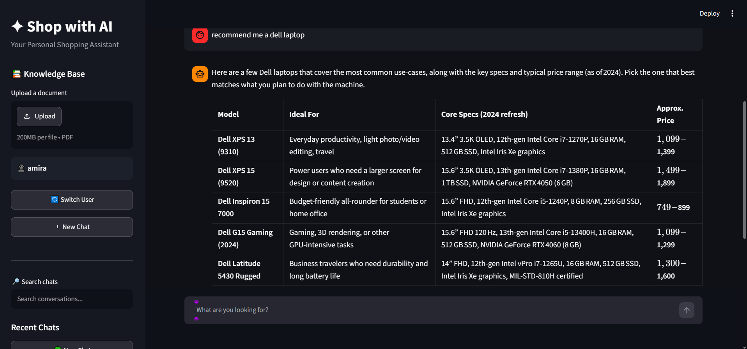

The application uses a modular setup:
- Graph Mechanics: Managed by LangGraph for stateful dialogue routing.
- API Gateway: LiteLLM Proxy manages model routing, keys, and fallbacks.
- Persistence & State: SQLite handles graph checkpoints and long-term user memory tracking.
- User Interface: Built with Streamlit to provide an interactive interface for chatting and document upload.

|
2.2 System Configuration & Unified Model Routing
2.2.1 Multi-Pool Load Balancing via LiteLLM
To separate operational tasks and avoid hitting single-key rate limits, ShopAI routes requests through LiteLLM into dedicated model groups:
- Agent Model Pool: Handles core reasoning, intent classification, and tool selection.
- Structured Response Pool: Handles output formatting into predefined schemas.
- Summary and Context Pool: Manages background operations such as conversation summarization and keyphrase extraction.
- Embedding Model Pool: Handles vector transformations for document ingestion and semantic search.
2.2.2 Router Configuration and Failover Strategies
LiteLLM is configured with basic retry and fallback mechanisms. If an API key encounters rate limits or upstream errors, the proxy temporarily routes requests to alternative keys, keeping the user session active.
2.3 Relational Persistence & State Checkpointing
2.3.1 Relational Database Architecture
Relational data is stored in SQLite across three main tables:
- User Entity: Stores user account records and session metadata.
- User Thread Entity: Maps unique conversation threads (thread_id) to specific users and stores thread titles.
- Long-Term Memory Entity: Stores user preferences (e.g., favorite brands, spending limits, size preferences) as key-value pairs for cross-session access.
2.3.2 LangGraph Execution Checkpointing
The LangGraph execution engine uses an asynchronous SQLite checkpointer (AsyncSqliteSaver). State updates are recorded at each graph transition, allowing users to pause, refresh, or switch threads in Streamlit without losing conversation history.
2.4 Graph Orchestration & Dynamic Routing
2.4.1 Intent-Driven Memory Routing
To save tokens, new user queries are evaluated by an initial routing node. If a query is a general question or does not require past user preferences, the engine skips SQLite memory fetching and routes directly to the primary agent.
2.4.2 Dynamic Context Truncation
To keep message history within model context constraints during long sessions, ShopAI uses a sliding-window strategy ($K=10$). The engine keeps the system prompt, retrieved long-term memory records, and the $K=10$most recent messages, preventing context overflow while preserving active session state.
2.4.3 ReAct Tool Execution and Finalization
The agent follows a ReAct execution flow. When the LLM calls a tool, execution routes to a tool execution node, runs the corresponding Python function, and appends the result to state as a tool message. Once all required information is available, control passes to a finalization node that formats the output.
2.5 Structured Output Schemas
To enforce structured data generation, Pydantic schemas are passed to the model:
- Product Comparison Schema: Formats item evaluations with fields for pros, cons, target user group, and value ratings.
- Shopping Plan Schema: Formats multi-item purchasing strategies, organizing items by priority, budget allocation, and reasoning.
- Review Summarization Schema: Structures feedback analysis into sentiment distributions, main strengths, common complaints, and usage recommendations.
2.6 Dashboard & User Interface Architecture
The UI is implemented as an asynchronous Streamlit web application connected to the SQLite database and LangGraph checkpointer:
- User Session Management: Handles basic user lookup and session initialization.
- Knowledge Base Ingestion Interface: Allows users to upload documents, which are parsed, chunked, and stored in ChromaDB.

- Thread Navigation Sidebar: Displays historical chat threads, loading selected threads directly from the database.
- Adaptive Thread Titling: Uses an LLM pass on the first message to generate a dynamic title for the thread.
- User Switch : users can switch accounts and all their previous chats is already saved
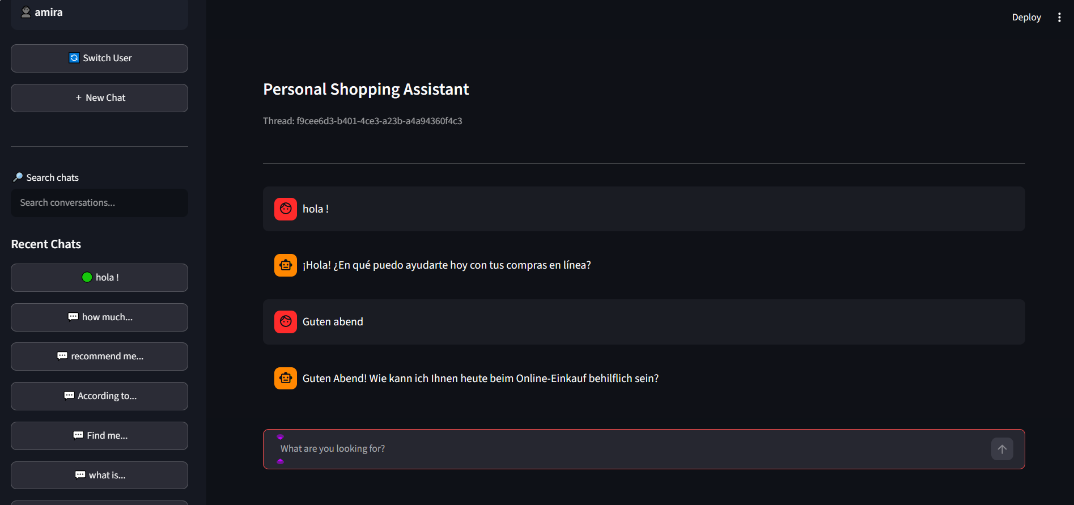

SECTION 3: RETRIEVAL-AUGMENTED GENERATION (RAG) PIPELINE DETAILS
3.1 Document Ingestion & Advanced Text Parsing
The ingestion pipeline converts unstructured documents into clean text while preserving structure. Instead of basic plain-text extraction, the project uses Docling to process uploaded documents into structured Markdown, retaining section headings, table layouts, and list formats.
3.2 Semantic Chunking Strategy
Fixed-character chunking often splits text in the middle of sentences or logical paragraphs. To maintain context continuity, the pipeline uses semantic chunking powered by sentence-transformers/all-MiniLM-L6-v2.
The algorithm calculates distance metrics between embeddings of adjacent sentences. A split is created when the semantic distance between consecutive sentences exceeds the 80th percentile threshold, keeping semantically cohesive passages intact.
3.3 Vector Representation & Normalization
Vector representations are generated using sentence-transformers/all-MiniLM-L6-v2. All output vectors undergo explicit $L_{2}$normalization
Normalizing vectors converts Euclidean distance calculations into cosine similarity comparisons, improving retrieval consistency in high-dimensional vector spaces. Document processing is capped at 100 documents per batch to avoid memory issues.
3.4 Hybrid Retrieval Architecture & Sparse-Dense Fusion

User Query ---> Dense Vector Search (Chroma / HNSW) ---> Rank List A --+
---> Sparse Keyword Search (BM25) ---> Rank List B --+--> Reciprocal Rank Fusion (RRF) ---> Top-5 Chunks

3.4.1 Dense Vector Retrieval
Dense search runs against a local Chroma vector database using HNSW indexing and cosine similarity. This captures conceptual and semantic context related to the user query.
3.4.2 Sparse Keyword Retrieval
Sparse retrieval uses a BM25 index built over the document collection. BM25 scores documents based on exact keyword matches and term frequency, helping retrieve specific product model numbers or technical terms.
3.4.3 Hybrid Fusion Mechanics
Results from both retrievers are merged using Reciprocal Rank Fusion (RRF) with equal weighting ($w_{\text{dense}}=0.5,w_{\text{sparse}}=0.5$)

where $k=60$is a smoothing constant, $M$is the set of retrievers, and $r_{m}\left(d\right)$is the rank of document $d$in retriever $m$. The top $k=5$ranked chunks are passed to the LLM for response synthesis.
3.5 Deduplication & Incremental Indexing Strategy
To avoid duplicate entries and save processing time during file updates, the ingestion pipeline uses an SQL Record Manager (record_manager_cache.sql).
The record manager stores document hashes, source paths, and collection keys (chroma/my_rag_collection). During ingestion, an incremental cleanup check compares incoming hashes against the database:
- New or modified documents are embedded and inserted.
- Obsolete chunks from deleted or updated files are purged.
- Unchanged files are skipped.
3.6 Prompt Engineering & Strict Context Enforcement
Retrieved chunks are formatted into a constrained QA system prompt to minimize hallucinations. The prompt requires the LLM to answer using only the retrieved context chunks. If the provided text does not contain enough information, the model returns a structured output with found = false and states that no relevant information was present.

SECTION 4: AGENT TOOL ECOSYSTEM & DOMAIN CAPABILITIES
4.1 Overview of the Multi-Tool Ecosystem
To handle domain tasks beyond static generation, the agent uses a set of custom tools. Instead of relying entirely on general model capabilities

4.2 Specialized Consumer Synthesis Tools
4.2.1 Product Recommendation Tool
Generates product suggestions based on user preferences, budget limits, and specific requirements. It can be combined with real-time web search to check pricing and availability before finalizing suggestions.
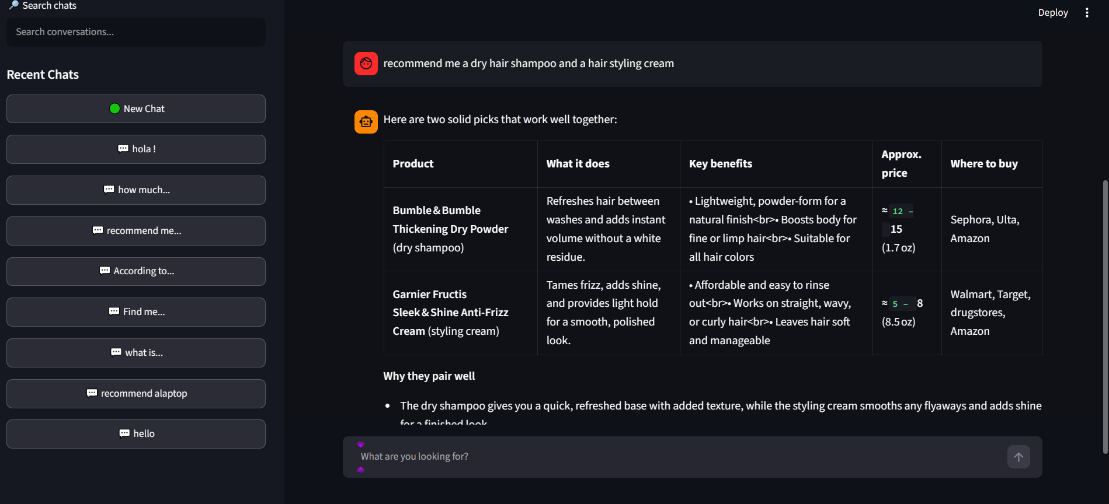
4.2.2 Product Comparison Tool
Processes evaluation queries across multiple products. It outputs structured comparison tables listing pros, cons, target users, and overall value metrics.
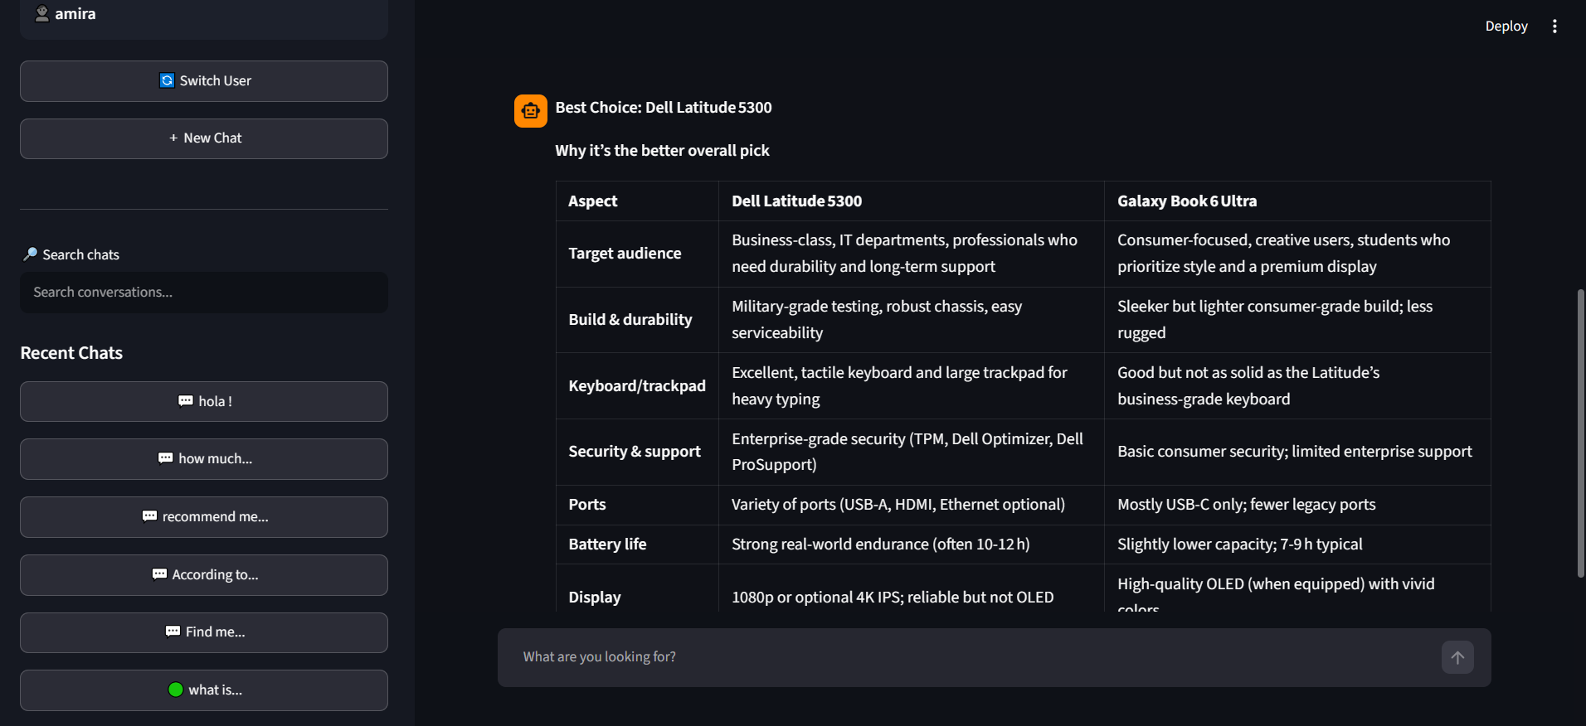
4.2.3 Review Summarization Tool
Extracts summary points from unstructured product reviews. It groups content into general sentiment, key positive features, common complaints, and recommended usage scenarios.

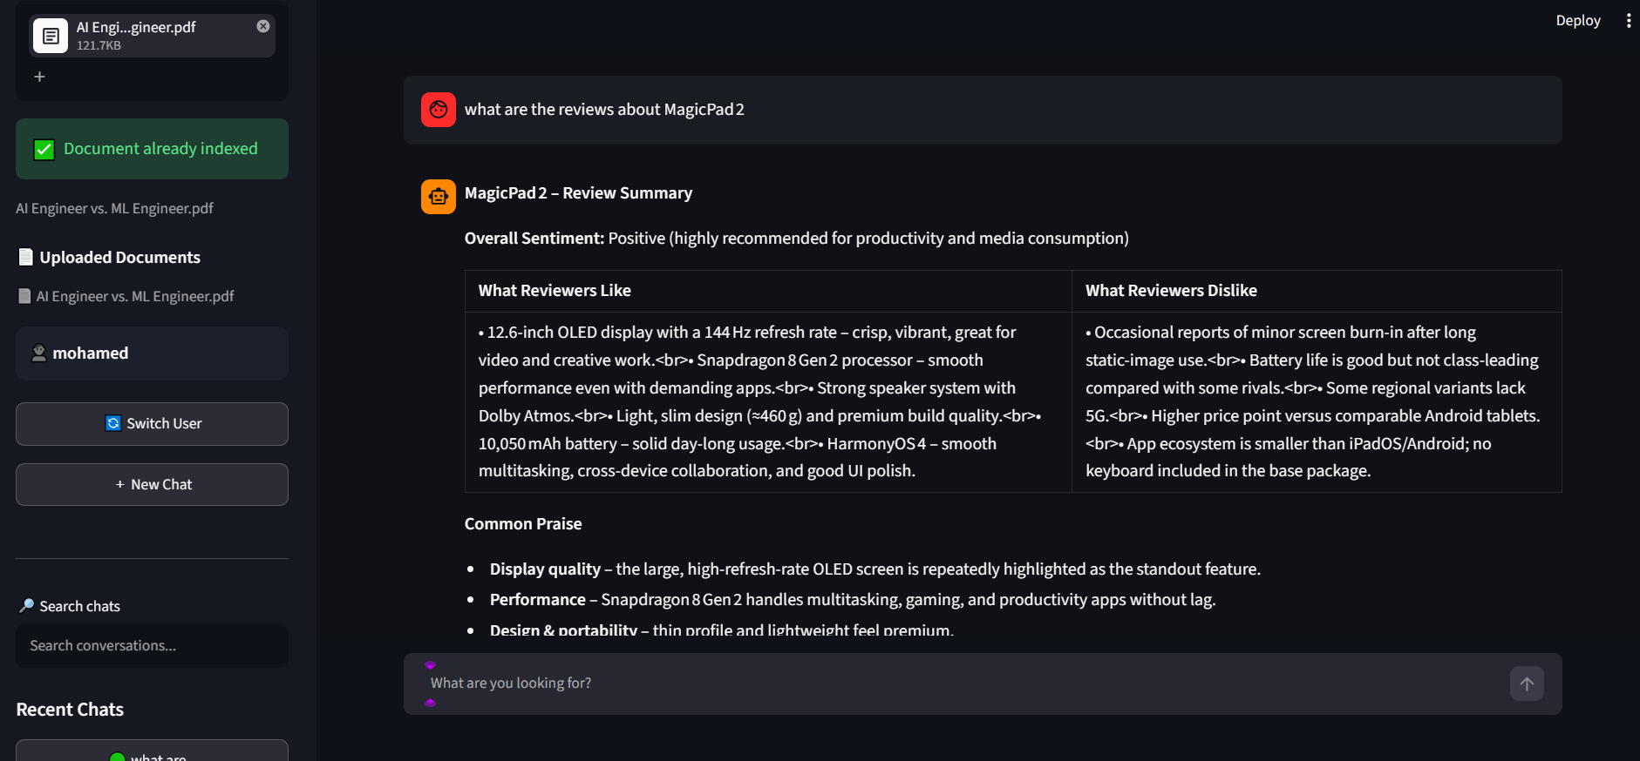
4.2.4 Shopping Plan Generation Tool
Generates purchasing plans for specific events or setups (e.g., home office setups, travel equipment). It categorizes items by priority, provides estimated price ranges, and explains the rationale for each item.

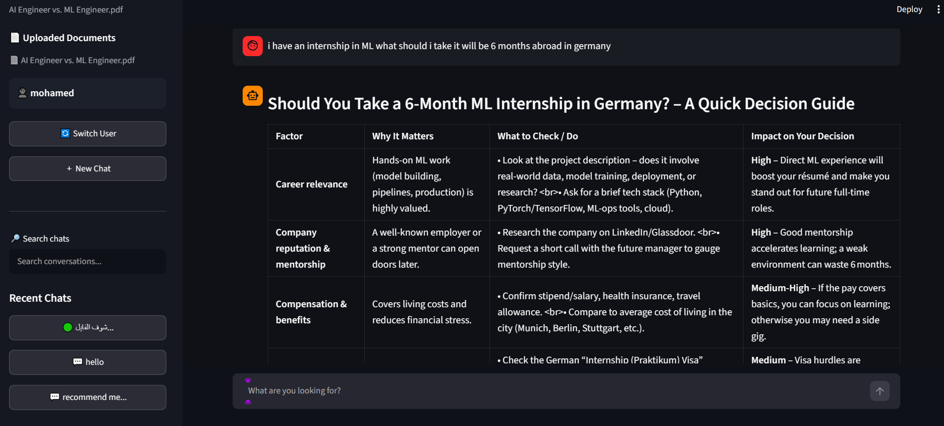
4.3 Web Search & Real-Time Market Retrieval Tool

To retrieve up-to-date pricing and information, the agent includes an asynchronous web search tool using the Tavily Search API. Returned search snippets are processed by an extraction
prompt that pulls out current prices, device specs, and active deals. Grounding constraints instruct the model not to infer unlisted prices.
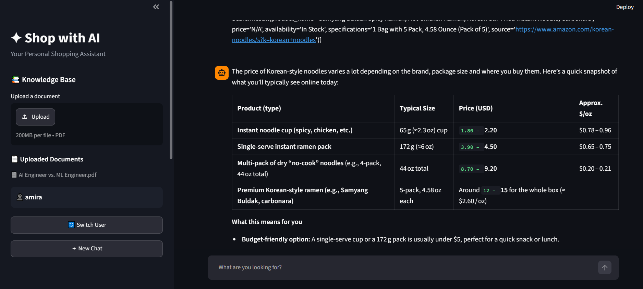

And Retrieve internal documents TOOL

Allows users to upload documents , get answers and information from a specific file
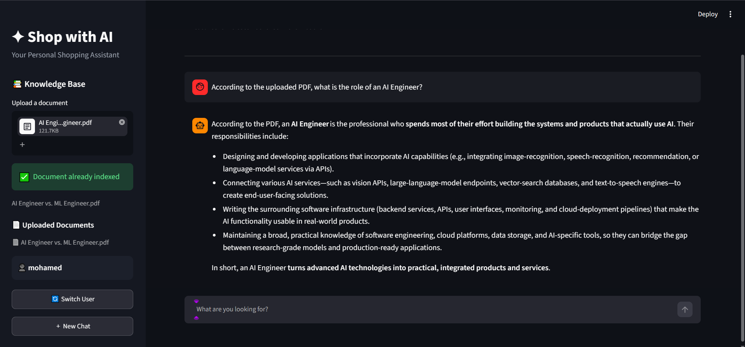

4.4 Long-Term Preference Memory Infrastructure
4.4.1 Memory Persistence Module
When a user explicitly mentions long-term preferences (e.g., preferred shoe brands, dietary or size constraints), the agent calls this tool. The module writes key-value pairs to the SQLite Long-Term Memory table mapped to the user ID.
4.4.2 Memory Retrieval Module
When processing user queries, the agent can call this module to query stored preference keys from SQLite, tailoring responses to the user's saved background information.
4.5 Internal Document Retrieval Tool
For queries involving uploaded documents, the agent uses an internal document search tool. This tool calls the hybrid retrieval pipeline (ChromaDB vector search + BM25 keyword search) and returns the top chunks along with source metadata and page numbers.

4.6 Final Response Formatting & Execution Termination
To ensure consistent outputs, the execution graph ends with a response submission tool. The tool accepts the final text answer, an array of cited sources, and a confidence metric. Executing this tool completes the graph loop and passes a validated JSON payload back to the Streamlit UI.
